TOWERS OF HANOI

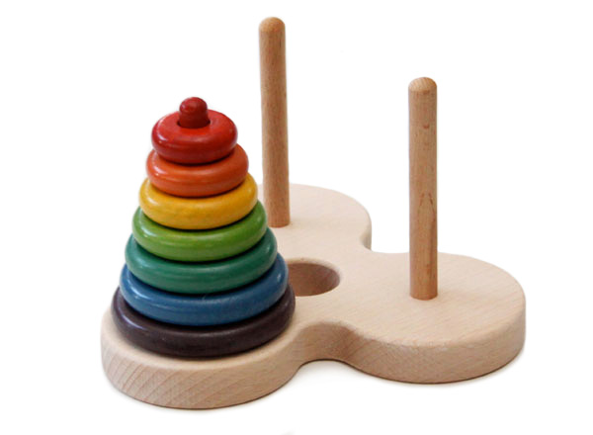

USER MANUAL

This program is a recreation of the towers of Hanoi, a mathematical game where the player has to move a certain number of discs, positioned in ascending order, from the first column to the third column (there are only three columns).

The program opens with a menu, which allows the user to choose whether they want to:

1. See a demonstration of how the Towers of Hanoi works
2. Play the Game
3. See the Game Rules
4. Exit the game

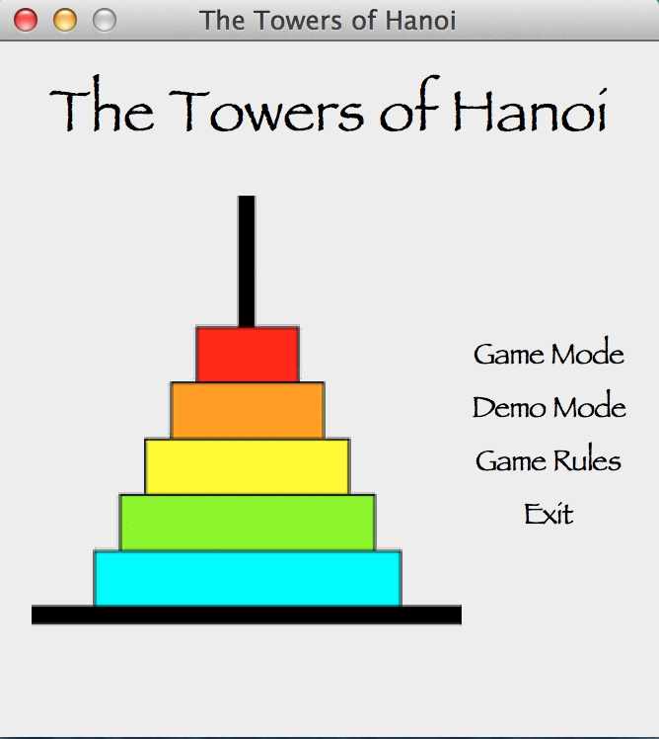

The selection can be made using the computer’s mouse.

If the user selects to play the game, the following will appear on the screen:

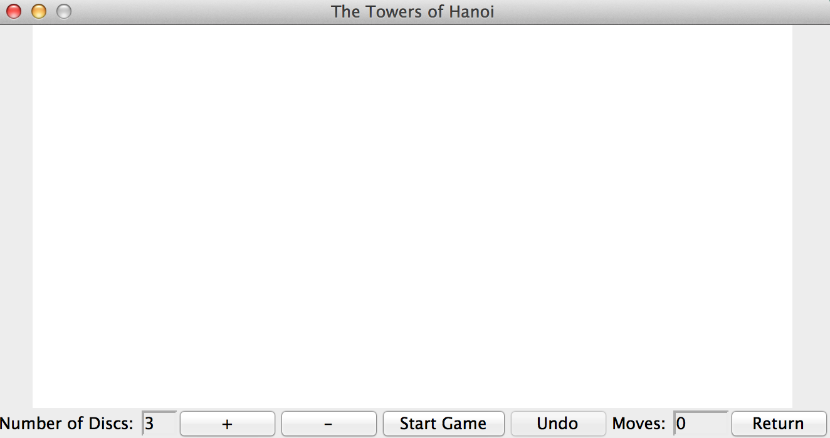

The “+” and “–“ buttons allow the player to choose the number of discs s/he wants; “+” increases the number by one, while “–“ decreases the number by 1. The maximum amount of discs is 8 while the minimum amount is 3.

The “undo” button undoes the previous moves.

The program also shows the number of moves the player made.

The “return” button asks the player if s/he wants to save the game, and then returns to the main menu.

In order to play the game, the user can just click and drag each disc to whatever column.

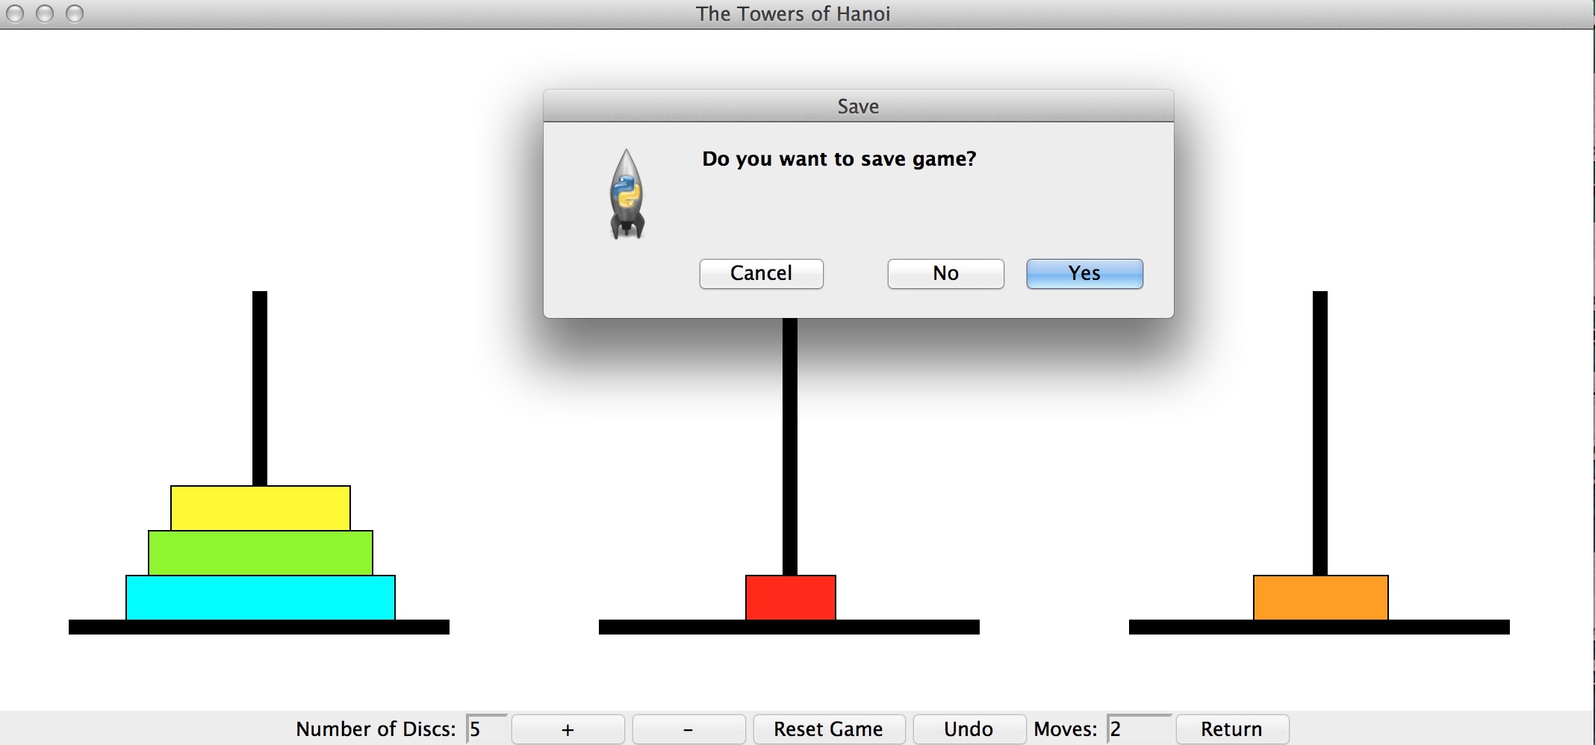

If the user selects to see the demonstration, the following will appear on the screen:

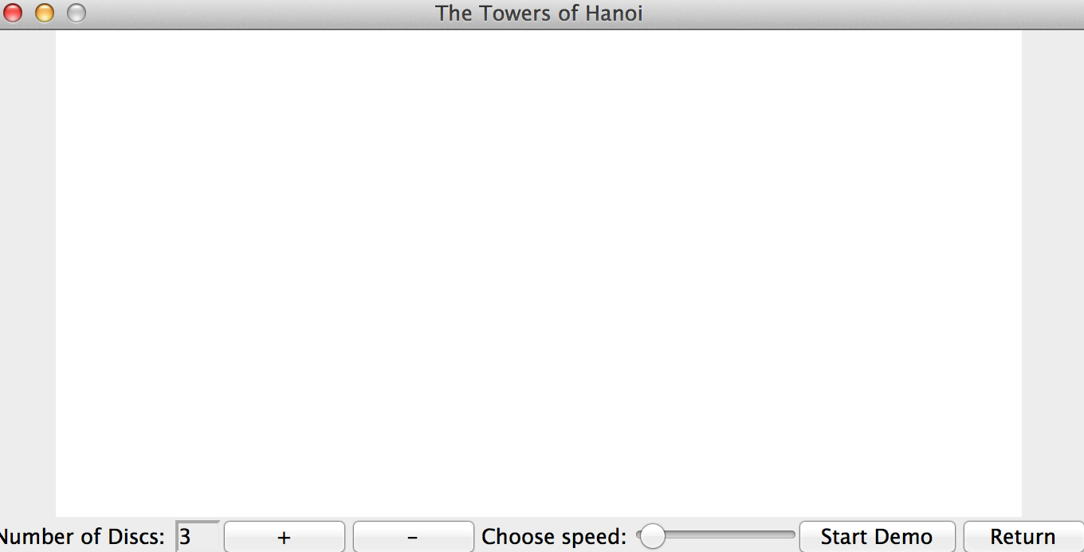

The “+”, “-“, and “return” buttons have the same purpose previously mentioned;

The only new thing is the “choose speed” cursor, which lets the user choose the speed of the game demonstration.

This is an example of what the demo should look like:

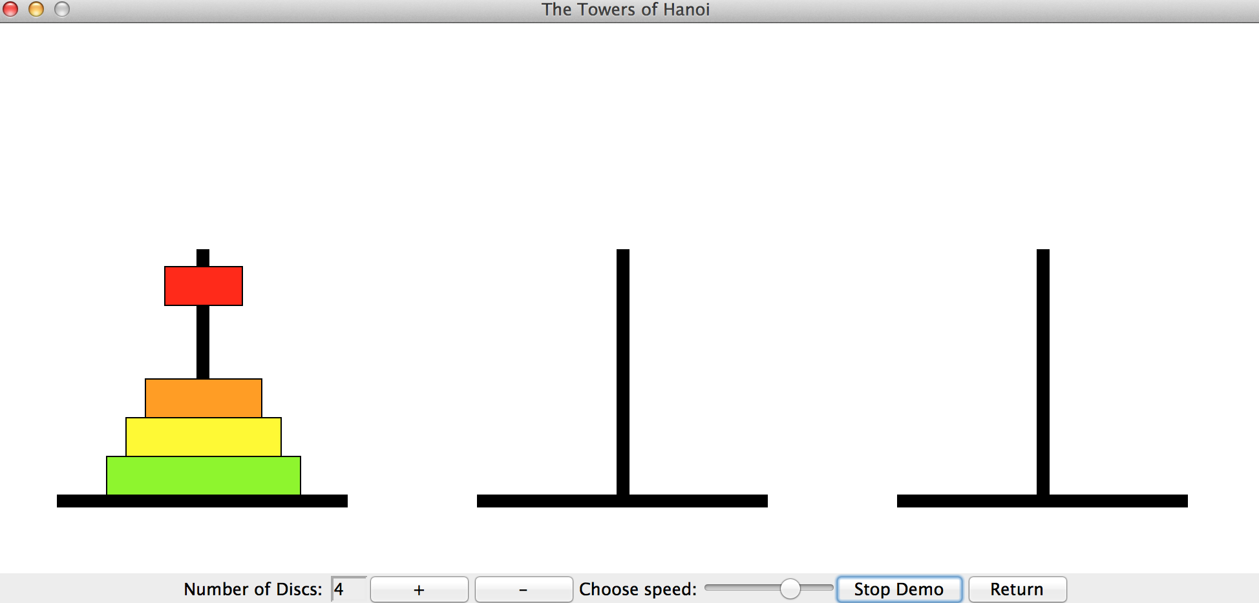

Once the player clicks “Start Demo”, each disc will move automatically one at a time and recreate the tower in the third column with the minimum number of moves needed.

If the player selects Game Rules, a window will appear on the screen that describes the game’s purpose and its rules. The “next” and “previous” buttons allow the player to navigate back and forth between pages, while the “return” button returns the player to the main menu.

